Process Improvement in Batch Put-up using Six Sigma

Erick C. Jones, Laderian. A., Pushparaj. S., Valiveti. R.

The authors

Erick C. Jones, Ph.D. is an Assistant professor at the University of Nebraska-Lincoln in Industrial and Management Systems Engineering Department. Areas of specialization and teaching include Supply Chain Management, Engineering Management, and Total Quality Management. He worked as an Industrial Engineering Consultant for the last 10 years, both in boutique and Big 5 consulting firms. His consulting ranged from Supply Chain Logistics to Organizational Strategy. He can be reached at ejones2@unl.edu
Laderian A. is a visiting instructor at the University of Nebraska-Lincoln in the Department of Industrial and Management Systems Engineering.
Pushparaj. S., Valiveti. R. are Graduate Students at the University of Nebraska-Lincoln in Industrial and Management Systems Engineering Department.

Keywords

Lean Six Sigma, One-way ANOVA, Metrics, Critical to Quality, Multi-Vari charts

Abstract

The concepts of Lean manufacturing and Six Sigma are used by various firms for better performance and productivity. Lean manufacturing refers to a method of doing more with fewer people, equipment, and space. Six Sigma is a disciplined and highly structured, quantitative approach to improving product or process quality. This paper deals with the application of Lean manufacturing and Six Sigma techniques in reducing the variation in the number of bags prepared by individual operators in the batch put-up production. One-way Analysis of Variance and Multi-Vari charts are used to identify the significant factors affecting the primary metric (Number of Bags per hour). The findings of this paper reveal that the operators, shifts and the ingredients per bag are the main contributing factors to be improved and a standard improvement process has been recommended.

1. INTRODUCTION
A large manufacturer in Lincoln, NE, is seeking to reduce the large variation in average operator output from batch put up of chemicals used in compounds mixed in a proprietary mix process. The mixers are the primary pieces of equipment for producing the compounds that are used for the manufacturer’s end products. Operated in batch mode, the mixers blend the raw materials together to form feedstock for the remaining processes. Materials are mixed several times to achieve the necessary properties and composition. [1] The high level process map of the company and the medium level process map around the problem area are included in Appendix.1 (a) and Appendix. 1 (b) respectively.
The average number of bags prepared by the operator ranges from 180 bags/shift to 320 bags/shift. The primary objective of the project is to reduce the operator output variation and benchmark a minimum number of bags an operator should put up thus increasing the productivity of the workers as well as reducing the downtime of the mixer. This reduction in variation in the number of bags put up by operators is anticipated to improve the productivity of the facility, cut down many costs and thus save money to the company. The operators cite different reasons such as number of blends, number of ingredients in each bag for the variation. With these problems facing the process owner, the issue of reduction in the variation of batch put up has never seemed more significant or immediate. The company adopted Lean Six Sigma in various quick changeover projects for continuous improvement. The includes and excludes grid of the process is included in Appendix.1(c). It shows the detailed breakdown of the batch put up process.

2. OVERVIEW OF LEAN SIX SIGMA
Six Sigma is a disciplined and highly structured, quantitative approach to improving product or process quality [2]. The goal of Six Sigma is one that strives for near perfection in meeting its customer requirements. The Six Sigma process uses data and rigorous statistical analysis to identify defects in a process or product, reduce variability, and achieve as close to zero defects as possible. The term Six Sigma itself refers to a statistically derived performance target of operating with only 3.4 defects for every million activities or opportunities [3]. It was first introduced at Motorola in 1986 in a bid to standardize the way defects were counted with Six Sigma being near perfection and became central to their strategy of delivering products that were fit for customers use. Motorola developed the program as a way of continuous improvement of their company and has gone on to implementing the program to improve almost every part of their business. The Six Sigma process includes the following stages:
Define: Clearly understand and state the problem, then capture the expertise of the team in theorizing what might be causing the process variation.
Measure: Collect reliable, objective data on the potential causes of variation.
Analyze: Study the data using graphical and/or statistical analysis tools to isolate the ‘critical few’ causes of variation.
Improve: Using the team’s expertise, develop and implement improvement actions to address the primary cause(s) of variation.
Control: Put in place ongoing measures to monitor both the process output and the factors that influence output variation, thus ensuring that if the process begins to wander, action can be taken quickly — before the process gets out of control. [7, 8]
The focus of Lean Manufacturing is around simplification – eliminating waste and non-value adding activities, removing the complexity from the process, assuring repeatability in tasks, and making operator friendly workplace. Six Sigma contributes to the consistency in the outputs produced at the lowest level of variation with respect to the factors that affect the most of the customers (critical to quality from customer’s point of view) [4, 5]. The central idea of the Six Sigma is to measure the defects in the process (i.e., 3.4 failures in one million attempts) and to systematically eliminate them. For increasing the pace of the business operations on the go, there is a need for rapid change, quick change over (QCO) process etc [4, 5]. Since Six Sigma is a gradual process, to improve the speed of the process, identify and eliminate the biggest time traps, Lean should be incorporated in Six Sigma. Lean Six Sigma is the methodology that maximizes shareholder value by achieving the fastest rate of improvement in customer satisfaction, cost, quality, process speed, and invested capital [5, 6]. The fusion of Lean and Six Sigma is required because Lean cannot bring a process under statistical control whereas Six Sigma alone cannot dramatically improve process speed or reduce invested capital. The Lean tools used in the project are 5S, Visual Factory and Ergonomics.

3. METHODOLOGY
The potential causes affecting the process are identified by the cause and effect diagram (appendix 5) from brainstorming. The main focus area was identified from the cause and effect diagram for the batch put-up production are number of bags per shift per operator, number of ingredients per bag, and the number of blends for each operator. A Quality Function Deployment (QFD) matrix was created to capture the voice of the customer. The KPOVs (Key Process Output Variables) are identified from the Fishbone diagram. The main KPIVs (Key Process Input Variables) are identified as operator, shift, ingredients per bag, and blends (appendix 6). Data were collected primarily through interviews with qualified personnel, observation of operators at work, and archival sources. A Pareto analysis was done for the operators vs. average number of bags per hour to prioritize the operators based on number of bags (appendix 7). The metrics were defined after several brainstorming sessions; the primary metric was identified as the average number of bags per hour per operator and the process secondary metrics that are critical to quality (CTQ’s) from the customer’s perspective are identified as loss of productivity in dollar value due to mixer downtime. One-way ANOVA (Analysis of Variance) [9, 11] was designed for this analysis and the significant factors are identified using this ANOVA model,

Average number of bags/hour = Operator + Shift + Ingredients/Bag + Blends

The dependent variable was “Average number of bags per hour” and the independent variables are identified as ‘Operator’, ‘Shift’, ‘Ingredients’ and ‘Blends’. The number of ingredients used was calculated for each bags prepared by the operator per shift. Blends were calculated separately as it was a separate operation, which took the operator away from bag put-up.

4. ANALYSIS
ANOVA was performed using SAS, the model used for this analysis is

Average number of bags per shift = Operator + Shift + Ingredients/Bag + Blends

The results from the analysis are given in table 1 and (appendix 2).
The ANOVA Procedure

Dependent Variable: Bags/Hour

Source DF ANOVA SS Mean Square F Value Pr > F

Operator 8 2117.503162 264.687895 5.04 <.0001
Shift 2 1403.838147 701.919074 13.36 <.0001
Ingredients/Bag 109 8171.357876 74.966586 1.43 0.0432
Blends 7 527.474797 75.353542 1.43 0.2020

Table 1

Results from ANOVA explain that ‘Blends’ is insignificant, the factors significantly affecting the Bags per hour are ‘Operators’, ‘Shift’ and ‘Ingredients/Bag’. Since the p-value for ‘Ingredients/Bag’ is 0.0432 it is significant at 0.05 level. R-square value is 0.73, which means that 27% of the unknown effects are affecting the process. Further focusing on the variables, the Blends were neutralized with the number of bags by considering the time taken by all the operators for the entire shift and their total number of bags. Then a time equivalent per bag (1.62 minutes per bag) was calculated. The average time taken for an operator to prepare a blend was pre-determined to be 25 minutes. From the equation-(1) the bag equivalent of a blend is determined and found to be 15.43 bags per blend, i.e. one blend is equivalent to 15.43 bags.
(Average time taken for preparing a Blend)
Blend Equivalent to Bags (BEB) = ---------- (1)
(Time for producing a Bag i.e. (1.62’ per bag))

Thus the blends are added to the bags and the ‘Average number of bags per shift’ was found again and ANOVA was performed for that, it is shown in table 2 and (appendix 3).
The ANOVA Procedure

Dependent Variable: New Bags/Hour

Source DF ANOVA SS Mean Square F Value Pr > F

Operator 8 3286.49211 410.81151 9.17 <.0001
Shift 2 2389.74645 1194.87322 26.66 <.0001
Ingredients/Bag 109 10337.05613 94.83538 2.12 0.0001

Table 2
The results from table 2 shows that ‘Operator’, ‘Shift’ and ‘Ingredients/Bag’ are the factors still affecting the ‘Bags/Hour’. The R-square is 0.79 which says that 21% of the variation is still unidentified. Since the ‘Ingredients/Bag’ is significant, the process owner’s hypothesis was accepted. Interaction effects between ‘Operator’ and ‘Ingredients/Bag’ were analyzed using the model,

Average number of bags per shift = Operator + Shift + Ingredients/Bag +
Operator*Ingredients/Bag

The ANOVA results for the interaction effects are shown in the table 3 (appendix4).
The ANOVA Procedure

Dependent Variable: Bags/Hour

Source DF ANOVA SS Mean Square F Value Pr > F

Operator 8 2117.50316 264.68790 28.90 <.0001
Shift 2 1403.83815 701.91907 76.63 <.0001
Operator*Ingredients/Bag 177 12987.03418 73.37307 8.01 <.0001

Table 3
The interaction effects show that the interaction between operator and the ingredients/bag are significant with an R-square value of 0.9863, which means the ANOVA model is used for the interaction, is the best model. Focusing on the operators and the shift a Multi-Vari chart [10] and Box plot was plotted in MINITAB for the operators and corresponding shifts to confirm the results from ANOVA (appendix 8, 9). Box plot for operators and the ingredients/bag was also plotted to confirm the results of interactions (appendix 10). A Matrix plot was plotted in MINITAB to see the overall effects.

5. DISCUSSION
From the analysis, over a period of six months, it is clear that the Operators, Shift and Ingredients/Bag are the significant factors affecting the process. The Multi-Vari charts shows that there is a large variation in the number of bags in each shift for each operator and this number reduces from shift 1 to shift 3. It is observed that all the operators are least productive in shift 3. The box plot also confirms this result. This is attributed to the presence of a supervisor in shift 1 and shift 2. Hence the presence of a supervisor is recommended in shift 3. Interaction effects for the Operator and Ingredients/Bag shows it is significant along with the main effects, so the number of ingredients/bag is also an important factor to be considered. The best and the least productive operators are videotaped, an important step in Quick Changeover (QCO), according to the OSHA guidelines (CPL 02-00-098 – CPL 2.98) for videotaping. The method of working is observed in both the cases and recommendations are made to improve the performance of the other operators. The performance of the best productive operator in shift 1 is observed as 43 bags per hour. It is observed from the box plot of bags per hour vs. shifts that about 35% operators in shift 1 and shift 2 made 35 bags per hour. Hence 35 bags per hour is set as the target for all the operators in all the shifts. Since the performance of the operators is the best in shift 1, it is recommended that the conditions prevailing in shift 1 should be retained for the other two shifts. The new target of 35 bags/operator/hour is expected to save at least $138,000/year to the company.

6. Prediction of Control Plan

As team members of the six sigma project we must be certain that improvement is maintained by implementing correct methods of control. Having natural variations around the expected average number of bags is a normal occurrence but if there are nonrandom variations, a stable control plan must be established to signal the special causes. Process control charts are graphs to show these assignable causes.
Since operator and shift are two major effective parameters in the batch put up process, process control charts must be set to monitor the process with respect to these two influential factors. The team decided to establish several statistical process control charts concerning the response variable, number of bags per shift, to control the process these charts are as followings:
- To establish statistical process control charts for every operator for all shifts.
- To establish statistical process control charts for all operators working on different shifts.
- To establish control charts for all operators working on any shift.
By reviewing several types of process control charts X bar and R charts seem adequate to control the batch put up process.
For an alternative control plan, it is possible to consider number of ingredients per shift for the above control charts.

7. FUTURE WORK
The improvements recommended in the previous section should be implemented accordingly. The 5S and Visual Factory techniques should be revised according to the guidelines. The performance of the operators should be measured after a period of two months and control charts should be plotted. The results should be compared against the target values. This process should be continued until the goal is reached and the new goal should be fixed then.

7. REFERENCES

1. Manufacturer’s data.
2. Hargrove, S.K. and Burge. L., (2002), Developing a Six-Sigma Methodology for Improving Retention in Engineering Education. 32nd ASEE/IEEE Frontiers in Education Conference.
3. Neuman. P and Cavanaugh. J.,(2000), The Six Sigma Way, McGraw-Hill.
4. Xagoraris, M. (2003), Six Sigma in action: How NCR has used it to improve its critical services, CMA Management.
5. Watson, G. H. (2003), A marriage of necessity: Lean and Six Sigma: Analysis Management, pp 16-17.
6. George, M. L. (2002), Lean Six Sigma: Combining Six Sigma Quality.
7. Vestal. W., (2004), Making the KM and Six Sigma Connection: Using KM to improve business processes, APQC, issue 3 (7).
8. Holtz, R., Campbell, P., (2000), Six Sigma: Its implementation in Ford’s facility management and maintenance functions. Journal of Facilities Management, 4 (2), pp 320-329. Henry Stewart Publications 1472-5967.
9. Norell. L., (2003), ANOVA Estimators Under Imbalance in the One-Way Random Model. Communications in Statistics, Theory and Methods, Vol. 32, No. 3, pp. 601–623.
10. Lipovetsky. S, Tishler. A, and Conklin. A. M., (2002) Multivariate least squares and its relation to other multivariate techniques. Appl. Stochastic Models Bus. Ind.; 18:347–356 (DOI: 10.1002/asmb.462).
11. Walpole, Myers. (2003), Probability and Statistics for Engineers and Scientists. pp. 463-470.

Appendix

Ticket
Mixing
(Gum batch Produced)
Sheeting
(Age limit countdown starts)
Hot House
(Internal storage)
Fabric roll
Slicing operation
Manufactured Product
Final Build Process
(Age limit countdown ends)

1(a): High Level Process Map

Receive
Material
Batch Put up
Mixer
Sheeting
Make
Product
Ship
Product
kkkk

Raw
Resin
Blends

Batch Put-up Chemicals

1(b): Medium level Process Map

Receive
Material
Load Material in carousel
Weigh Material
Label
Check specification
sheet
Bag Count
Mixer
Load material in blender
Blend the materials

1(c): Includes/Excludes Grid

The SAS System 10:31 Friday, December 3, 2004

The ANOVA Procedure

Class Level Information

Class Levels Values

Operator 9 1 2 3 4 5 6 7 8 9

Shift 3 1 2 3

Ingredients/Bag 110 0.09 0.87 0.95 1 1.03 1.04 1.05 1.06 1.09 1.1 1.11 1.12 1.13 1.15 1.16
1.18 1.21 1.22 1.23 1.24 1.25 1.26 1.27 1.28 1.29 1.3 1.31 1.32 1.33 1.34
1.35 1.36 1.37 1.38 1.39 1.4 1.41 1.42 1.43 1.44 1.45 1.46 1.47 1.48 1.49
1.5 1.51 1.52 1.53 1.55 1.56 1.57 1.58 1.59 1.6 1.61 1.62 1.63 1.64 1.65
1.67 1.69 1.71 1.72 1.73 1.74 1.77 1.81 1.85 1.87 1.88 1.9 1.92 1.94 1.96
1.97 1.98 1.99 2.02 2.03 2.07 2.08 2.11 2.12 2.18 2.2 2.21 2.25 2.26 2.28
2.33 2.35 2.37 2.53 2.58 2.66 2.67 2.74 2.77 2.81 2.87 2.92 3.11 3.21 3.3
3.32 3.48 3.75 4.04 4.28

Blends 8 0 1 2 3 4 5 6 7

Bags/Hour 144 6 9.5 11.88 12 12.75 13.88 14.08 15 15.83 16 16.63 16.75 16.88 17.13 17.43
17.5 17.63 17.92 18.5 18.75 18.88 19.25 19.38 19.5 19.63 19.75 19.88 20
20.13 20.25 20.5 20.63 20.75 20.88 21 21.13 21.75 22.13 22.38 22.44 22.5
22.63 22.75 23 23.13 23.17 23.25 23.38 23.55 23.63 23.75 23.81 23.88 24
24.11 24.25 24.38 24.5 24.63 24.75 25.33 25.44 25.5 25.75 25.83 25.88 26
26.25 26.38 26.5 26.75 26.86 26.88 26.94 27 27.25 27.38 27.5 27.6 27.63
27.75 27.88 28.25 28.5 28.75 28.88 29 29.75 30.25 30.38 30.5 30.75 30.88
30.91 31 31.06 31.13 31.25 31.38 31.63 31.69 31.75 31.88 32 32.13 32.75
33.33 33.38 33.5 33.75 34 34.38 34.5 34.63 34.75 35 35.25 35.38 35.88 36
36.25 36.38 36.5 36.75 37.25 37.88 38.25 38.5 39.25 39.75 40 40.25 40.38
41.75 42.25 42.5 43.67 44.75 45 47.5 53.25 63.63 65 66.25

Number of observations 213

The SAS System 10:31 Friday, December 3, 2004

The ANOVA Procedure

Dependent Variable: Bags/Hour

Sum of
Source DF Squares Mean Square F Value Pr > F

Model 126 12220.17398 96.98551 1.85 0.0013

Error 86 4517.18412 52.52540

Corrected Total 212 16737.35810

R-Square Coeff Var Root MSE Bags/Hour Mean

0.730114 26.46666 7.247441 27.38329

Source DF Anova SS Mean Square F Value Pr > F

Operator 8 2117.503162 264.687895 5.04 <.0001
Shift 2 1403.838147 701.919074 13.36 <.0001
Ingredients/Bag 109 8171.357876 74.966586 1.43 0.0432
Blends 7 527.474797 75.353542 1.43 0.2020

Appendix 2
The SAS System 10:31 Friday, December 3, 2004

The ANOVA Procedure

Class Level Information

Class Levels Values

Operator 9 1 2 3 4 5 6 7 8 9

Shift 3 1 2 3

Ingredients/Bag 110 0.09 0.87 0.95 1 1.03 1.04 1.05 1.06 1.09 1.1 1.11 1.12 1.13 1.15 1.16
1.18 1.21 1.22 1.23 1.24 1.25 1.26 1.27 1.28 1.29 1.3 1.31 1.32 1.33 1.34
1.35 1.36 1.37 1.38 1.39 1.4 1.41 1.42 1.43 1.44 1.45 1.46 1.47 1.48 1.49
1.5 1.51 1.52 1.53 1.55 1.56 1.57 1.58 1.59 1.6 1.61 1.62 1.63 1.64 1.65
1.67 1.69 1.71 1.72 1.73 1.74 1.77 1.81 1.85 1.87 1.88 1.9 1.92 1.94 1.96
1.97 1.98 1.99 2.02 2.03 2.07 2.08 2.11 2.12 2.18 2.2 2.21 2.25 2.26 2.28
2.33 2.35 2.37 2.53 2.58 2.66 2.67 2.74 2.77 2.81 2.87 2.92 3.11 3.21 3.3
3.32 3.48 3.75 4.04 4.28

Bags/Hour 182 6 9.5 11.88 12.75 15.8 15.86 16.61 16.63 16.66 16.75 16.88 16.93 17.13
17.5 17.63 17.93 18.5 18.75 18.88 19.05 19.25 19.38 19.63 19.69 19.75
19.88 20 20.63 20.75 21 21.13 21.43 21.55 21.68 21.77 21.93 22.05 22.13
22.38 22.43 22.44 22.5 22.63 22.75 22.8 23 23.04 23.05 23.17 23.25 23.36
23.38 23.63 23.81 23.88 24.38 24.5 24.95 25.05 25.15 25.33 25.34 25.55
25.61 25.88 26.04 26.18 26.3 26.32 26.36 26.43 26.5 26.86 26.94 27 27.25
27.48 27.5 27.6 27.68 27.72 27.8 27.86 28.11 28.3 28.32 28.33 28.43 28.48
28.5 28.61 28.75 28.84 29 29.25 29.3 29.55 29.69 29.75 30.11 30.18 30.36
30.43 30.5 30.61 30.8 30.84 31.13 31.25 31.36 31.38 31.39 31.61 31.75 32
32.13 32.18 32.3 32.31 32.66 32.68 32.75 32.93 33.05 33.22 33.33 33.55
33.62 33.8 33.93 34 34.38 34.5 34.61 34.73 34.92 34.98 35 35.11 35.25 35.3
35.43 36 36.3 36.55 36.61 36.66 36.68 37.36 37.61 37.79 38.25 38.5 39.07
39.25 39.8 40 40.38 41.11 41.16 41.66 41.68 41.75 42.04 42.16 42.25 42.54
43.61 43.67 44.22 44.64 44.75 45.97 46.04 46.93 48.29 51.36 51.72 53.25
70.14 71.34 72.04

Number of observations 213

The SAS System 10:31 Friday, December 3, 2004

The ANOVA Procedure

Dependent Variable: Bags/Hour

Sum of
Source DF Squares Mean Square F Value Pr > F

Model 119 16013.29469 134.56550 3.00 <.0001

Error 93 4167.39487 44.81070

Corrected Total 212 20180.68956

R-Square Coeff Var Root MSE Bags/Hour Mean

0.793496 22.72934 6.694079 29.45127

Source DF Anova SS Mean Square F Value Pr > F

Operator 8 3286.49211 410.81151 9.17 <.0001
Shift 2 2389.74645 1194.87322 26.66 <.0001
Ingredients/Bag 109 10337.05613 94.83538 2.12 0.0001

Appendix 3
The SAS System 10:31 Friday, December 3, 2004

The ANOVA Procedure

Class Level Information

Class Levels Values

Operator 9 1 2 3 4 5 6 7 8 9

Shift 3 1 2 3

Ingredients/Bag 110 0.09 0.87 0.95 1 1.03 1.04 1.05 1.06 1.09 1.1 1.11 1.12 1.13 1.15 1.16
1.18 1.21 1.22 1.23 1.24 1.25 1.26 1.27 1.28 1.29 1.3 1.31 1.32 1.33 1.34
1.35 1.36 1.37 1.38 1.39 1.4 1.41 1.42 1.43 1.44 1.45 1.46 1.47 1.48 1.49
1.5 1.51 1.52 1.53 1.55 1.56 1.57 1.58 1.59 1.6 1.61 1.62 1.63 1.64 1.65
1.67 1.69 1.71 1.72 1.73 1.74 1.77 1.81 1.85 1.87 1.88 1.9 1.92 1.94 1.96
1.97 1.98 1.99 2.02 2.03 2.07 2.08 2.11 2.12 2.18 2.2 2.21 2.25 2.26 2.28
2.33 2.35 2.37 2.53 2.58 2.66 2.67 2.74 2.77 2.81 2.87 2.92 3.11 3.21 3.3
3.32 3.48 3.75 4.04 4.28

Blends 8 0 1 2 3 4 5 6 7

Bags/Hour 144 6 9.5 11.88 12 12.75 13.88 14.08 15 15.83 16 16.63 16.75 16.88 17.13 17.43
17.5 17.63 17.92 18.5 18.75 18.88 19.25 19.38 19.5 19.63 19.75 19.88 20
20.13 20.25 20.5 20.63 20.75 20.88 21 21.13 21.75 22.13 22.38 22.44 22.5
22.63 22.75 23 23.13 23.17 23.25 23.38 23.55 23.63 23.75 23.81 23.88 24
24.11 24.25 24.38 24.5 24.63 24.75 25.33 25.44 25.5 25.75 25.83 25.88 26
26.25 26.38 26.5 26.75 26.86 26.88 26.94 27 27.25 27.38 27.5 27.6 27.63
27.75 27.88 28.25 28.5 28.75 28.88 29 29.75 30.25 30.38 30.5 30.75 30.88
30.91 31 31.06 31.13 31.25 31.38 31.63 31.69 31.75 31.88 32 32.13 32.75
33.33 33.38 33.5 33.75 34 34.38 34.5 34.63 34.75 35 35.25 35.38 35.88 36
36.25 36.38 36.5 36.75 37.25 37.88 38.25 38.5 39.25 39.75 40 40.25 40.38
41.75 42.25 42.5 43.67 44.75 45 47.5 53.25 63.63 65 66.25

Number of observations 213

The SAS System 10:31 Friday, December 3, 2004

The ANOVA Procedure

Dependent Variable: Bags/Hour

Sum of
Source DF Squares Mean Square F Value Pr > F

Model 187 16508.37549 88.28008 9.64 <.0001

Error 25 228.98261 9.15930

Corrected Total 212 16737.35810

R-Square Coeff Var Root MSE Bags/Hour Mean

0.986319 11.05212 3.026434 27.38329

Source DF Anova SS Mean Square F Value Pr > F

Operator 8 2117.50316 264.68790 28.90 <.0001
Shift 2 1403.83815 701.91907 76.63 <.0001
Operator*Ingredients/Bag 177 12987.03418 73.37307 8.01 <.0001

Appendix 4

Fish Bone Diagram

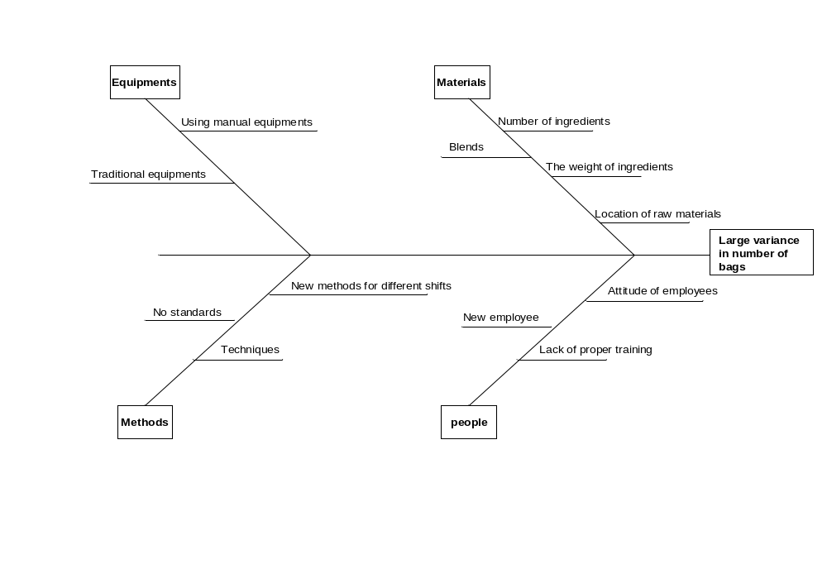

Appendix 5

Quality Function Deployment

The KPOVs (Key Process Output Variables) are identified as variation in the number of bags and the mixer downtime. Customer priority ratings (CPR) are assigned as 10 and 9 respectively. The KPIVs (Key Process Input Variables) are operators, number of ingredients, shifts, blends, arrangement of workplace, testing department, accuracy in scaling, and pyramid weighing. The Effect of each of the KPIVs is shown in the function deployment matrix. The rating is calculated as ∑ (CPR * Effect) and ranking is given accordingly.

 | Quality Function Deployment | KPOVs | Variations in number of bags | Mixer downtime | Ratings | Rank
 |  | CPR # | 10 | 9
 | KPIVs
1. | Operators |  | 10 | 9 | 181 | 1*
2. | Number of ingredients |  | 8 | 7 | 143 | 3*
3. | Shifts |  | 10 | 5 | 145 | 2*
4. | Blends |  | 9 | 5 | 135 | 4
5. | Arrangement of workplace |  | 5 | 3 | 77 | 7
6. | Testing department |  | 0 | 7 | 63 | 8
7. | Accuracy in scaling |  | 6 | 5 | 105 | 6
8. | Pyramid weighing |  | 5 | 8 | 122 | 5

Appendix 6

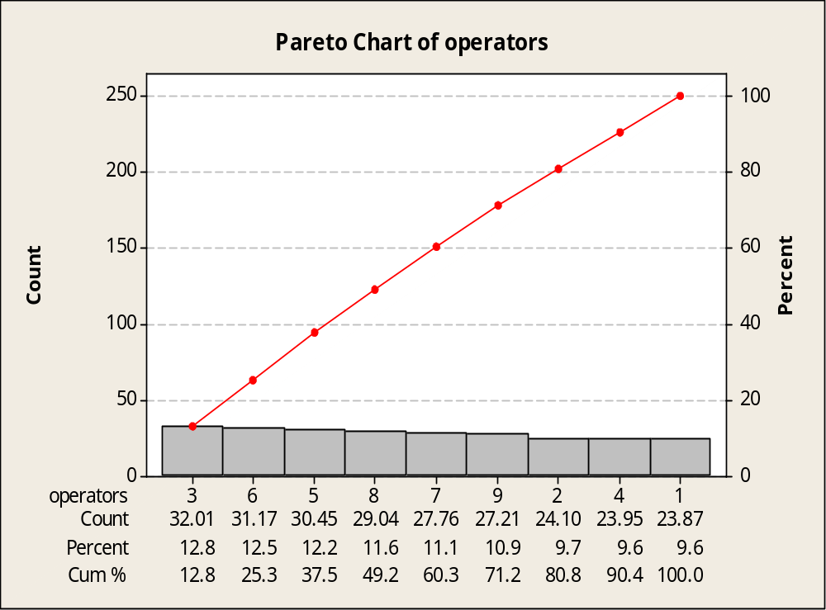

Appendix 7

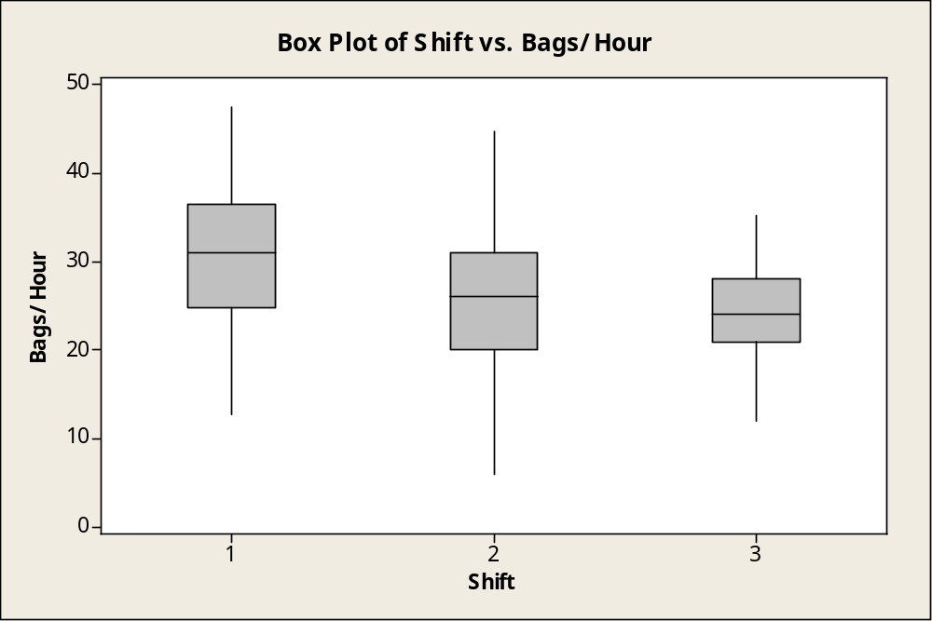

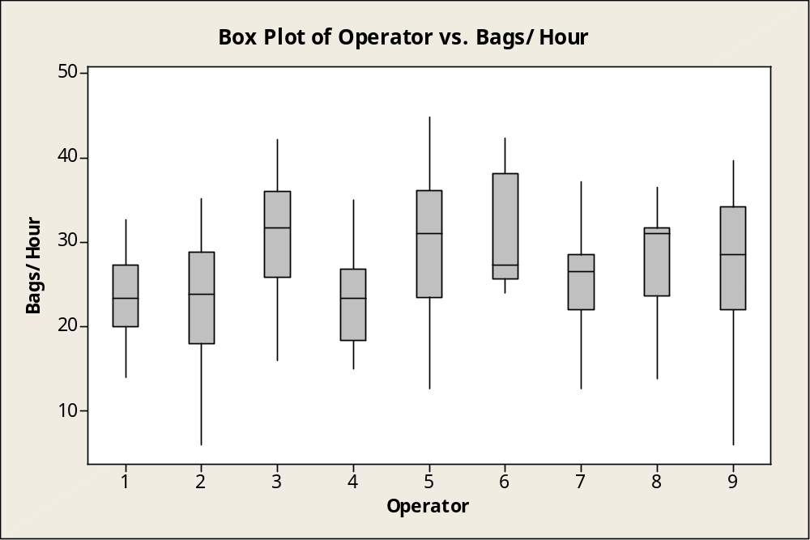

Appendix 8
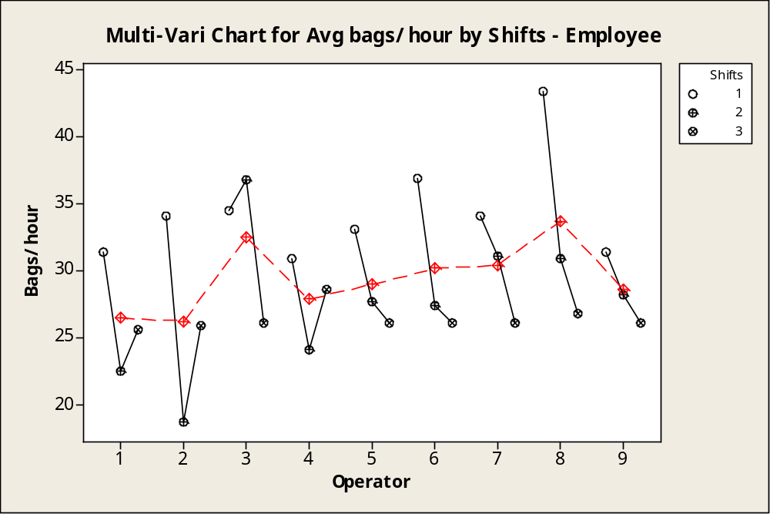

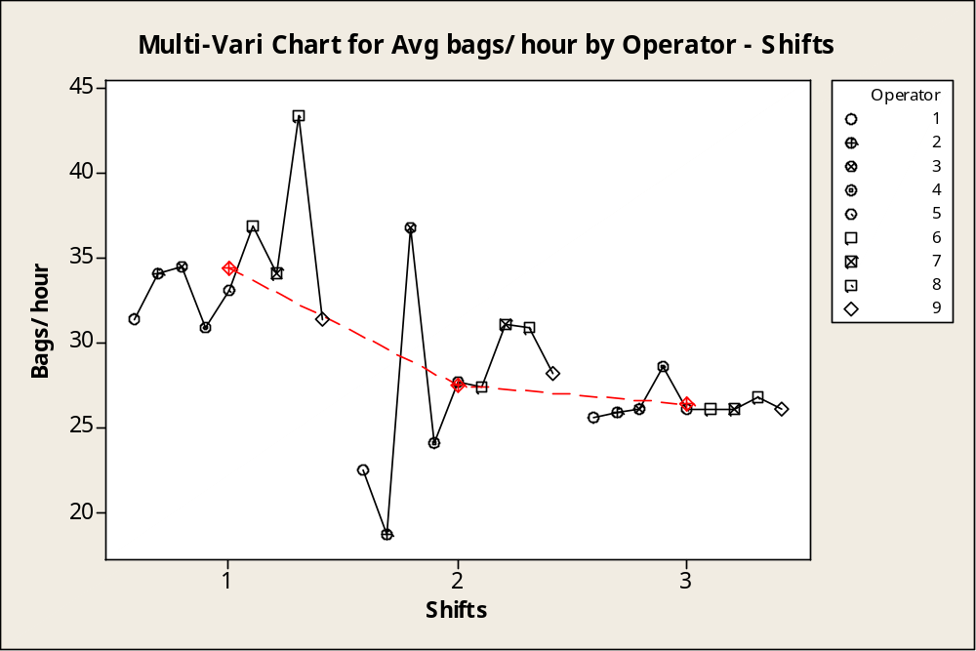Appendix 9
Interaction plot for operators vs. ingredients/bag
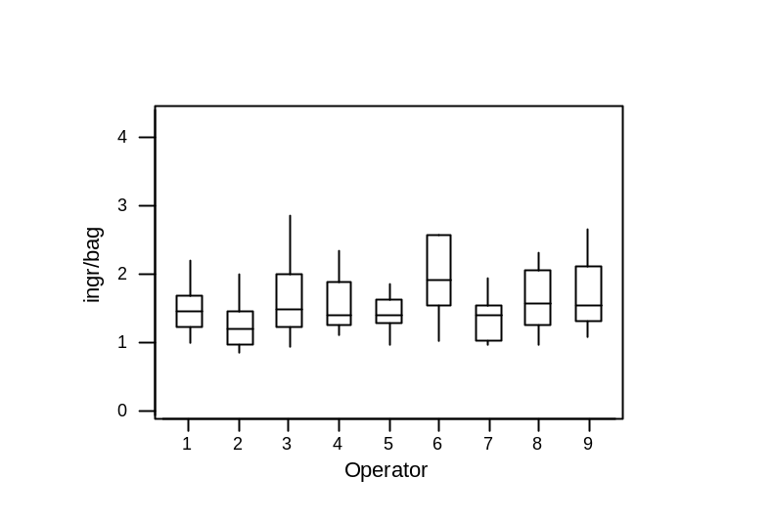
Appendix 10

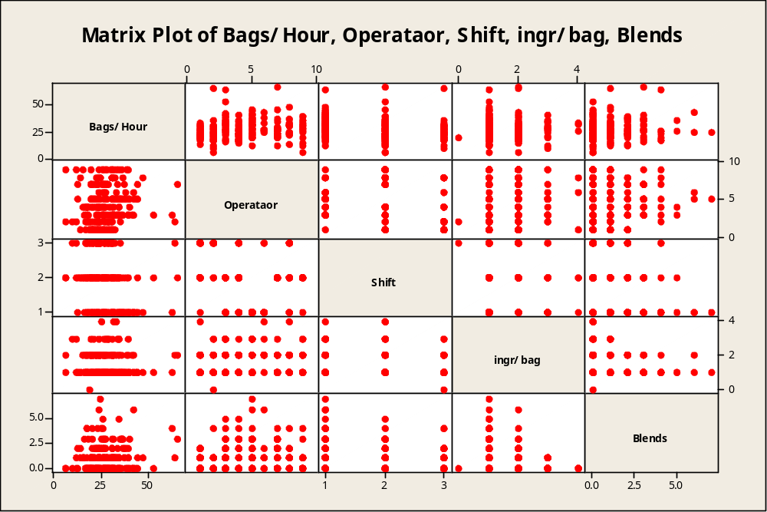

Appendix 11

